

**IA512002 Fundamentals of Web Development**

**Assessment 2 – Individual Project**

|  |  |  |  |  |  |  |  |
| --- | --- | --- | --- | --- | --- | --- | --- |
| **Study block** | Study Block 1 - 2024 | | | | | | |
| **Date issued** | 19/02/2024 | | | | | | |
| **Due dates** | 02/04/2024 (Evidence Portfolio) | **Time** | | 11.59 PM | | | |
| 03/04/2024 (Presentation and Defense) | During class time | | | |
| **Delivery:** | Submit to Moodle before the deadline, and present and defend | | | | | | |
| **Weighting** | 70% | | | | | | |
| **Marks out of** | 100 | | | | | | |
| **Instructions** | 1. Complete this cover sheet and submit it with your Evidence Portfolio. Your Evidence Portfolio consists of the following:    1. Project Report as a .docx file using the Template provided on Moodle,    2. Slides of your Presentation as a .pptx file, and    3. Code as a single .zip file which should be named using your first name. (e.g. jane.zip) 2. You must Present AND Explain the work submitted, during the time allocated. Failure to present and defend the work you submit may result in a zero mark being awarded and disciplinary action being taken.  * This assignment must be your own work. * Collusion, copying or plagiarism may result in disciplinary action. * We advise that you keep a copy of this assignment. * Refer to following website for reference related resources:   <http://www.cite.auckland.ac.nz/index.php?p=quickcite> | | | | | | |
| **Student Name** | Satyam Bhatt | | | | | | |
| **Student ID No** | 1000122510 | | | | | | |
| **Lecturer** | Ganeshan | | **Class time** | | | 8.30 – 12.30 pm | |
| **Student declaration:** | I confirm that:  *This is an original assessment and is entirely my own work.*  *Where ideas, tables, diagrams etc. of other writers have been used, I have acknowledged the source in every case.*  *This assignment has not been, nor will be, submitted as assessed work for any other academic course.* | | | | | | |
| **Signature of student:** |  | | | | **Date** | |  |



Project Report

Wine Sipper

Table of Contents

❖ Executive Summary 4

❖ Introduction 4

❖ Scope 5

❖ Use cases 6

❖ Use Case Diagram 7

❖ Software Development Methodology 9

❖ Project Timeline 9

❖ Known Bugs and Limitations 10

❖ Reflection 11

❖ Reference 11

Satyam Bhatt

Web Development

## Executive Summary

I designed and developed a web application using HTML, CSS, JavaScript, Node.Js, and Express.Js for an online wine catalog called ‘Wine Sipper’

The Wine Catalogue Project aims to transform the online wine exploration experience by offering a curated selection of wines from around the world. With the rising interest in wine culture and the shift towards digital platforms for wine discovery, there is a clear demand for a user-friendly and comprehensive online catalog.

Our platform will provide descriptions, and tasting notes to assist users in making informed decisions. Through the integration of technology and passion for wine, Wine Sipper aims to enhance the wine discovery journey and build a vibrant community of wine lovers.

In summary, the Wine Catalog Project represents an exciting opportunity to combine passion with technology, providing a valuable resource for wine enthusiasts while contributing to the digital advancement of the wine industry.

## Introduction

WineSipper is an online wine catalog, which hosts tailor-made wines selected from some of the best wine regions of the world.

This platform serves as a digital sanctuary where individuals immerse themselves in the rich tapestry of wine culture, embracing a world of diverse flavors, varietals, and traditions. WineSipper caters to a diverse spectrum of wine enthusiasts, fostering a vibrant community united by a shared passion for viniculture.

At WineSipper, we curate a meticulously selected collection of wines, ranging from iconic vintages to hidden gems, ensuring that each bottle encapsulates a unique narrative waiting to be discovered. Our platform empowers users to explore this curated selection with confidence, offering personalized recommendations, expert insights, and immersive educational resources to enrich their wine journey.

As we embark on this journey, WineSipper remains committed to delivering excellence in every facet of our platform, from the quality of our wine selection to the depth of our user experience. With an unwavering dedication to innovation, authenticity, and customer satisfaction, WineSipper invites you to uncork the possibilities and embark on an unforgettable voyage through the world of wine.

## Scope

WineSipper aims to revolutionize the wine industry by providing a sophisticated online platform that caters to wine enthusiasts, connoisseurs, and novices alike. Our platform serves as a digital hub where users can explore, discover, and appreciate the diverse world of wines from around the globe. WineSipper seeks to create a vibrant and engaging community centered around the shared passion for viniculture, offering an immersive experience.

* **Objective:**

The primary objectives of the WineSipper project include:

* Developing an intuitive and user-friendly online platform for browsing.
* Curating a diverse and high-quality selection of wines from renowned vineyards and regions worldwide.
* Allowing registered users to add the wines of their liking to the catalogue, and even adding reviews to help us improve.
* **Key Deliverables:**

The main deliverables of the WineSipper project include:

* Development of a responsive and visually appealing website.
* Creation of a curated wine catalog featuring a wide range of varietals, regions, and price points.
* Implementation of user authentication including user profiles.
* Implementation of a user-friendly interface that enables users to seamlessly add wines to the catalog and leave a review/s.
* **Functionalities:**

WineSipper will offer the following functionalities to users:

* User registration and authentication for personalized experiences.
* Viewing detailed wine descriptions, including tasting notes, ratings, and reviews from other users.
* Adding wines of their liking and even writing a review to help us improve.
* **Technical Requirements:**

The WineSipper project will require:

* Development using modern web development technologies, such as HTML, CSS, JavaScript, and frameworks like Jira.
* Web Servers to host the web application, Node.Js with Express.js is being used for this purpose.
* Integration with backend technologies for user authentication, and database management, such as Node.js, Express.js, and MySQL.
* For database management, I'm using MySQL via XAMPP.
* Session management is handled by ‘express-session’ middleware.
* I’m using ‘.ejs’ as my view engine to render the needed content.
* For form handling, GET and POST methods are being implemented by me.
* **Why did I choose this project?**

The choice to pursue this topic stems from my passion for wine and the growing demand for digital solutions in the wine industry. By combining my love for wine with my technical skills, I aim to create a valuable online platform that caters to wine enthusiasts while contributing to the digital transformation of the industry.

## Use cases

**Use Case 1:** User Registration and Profile Creation

**Actor:** New User

**Goal:** To join WineSipper and create a profile.

**Main Flow:**

* Users visit the WineSipper website and look for the "Register" button.
* Users are asked to pick a username and password to secure their account.
* After entering their chosen details, they click the register button.
* WineSipper checks your information to make sure everything is correct.
* System creates a new account and stores it in the database.

**Use Case 2:** Exploring Wines

**Actor:** Registered User

**Goal:** To browse through the wine catalog on WineSipper.

**Main Flow:**

* Users start on the WineSipper homepage and begin browsing through different categories like still or sparkling wines.
* Selecting a category, you're presented with a variety of wines along with details like name, type, and price.
* Clicking on a specific category, you can read more about it, including descriptions and tasting notes.
* Registered users can also add sparkling wines of their choice using the ‘add wines’ feature.

**Use Case 3:** Sharing Your Thoughts on Wine

**Actor:** Registered User

**Goal:** To share your opinions and experiences by submitting a review.

**Main Flow:**

* Users head over to the reviews section of WineSipper to see what others are saying.
* Users can decide to add their own by clicking on the "Submit Review" option.
* WineSipper asks you to provide your name, a rating between 1 to 5 stars, and any comments you have.
* Once users have filled in the details, they submit their review.
* WineSipper checks everything over and then adds your review to the collection for others to see.

## Use Case Diagram

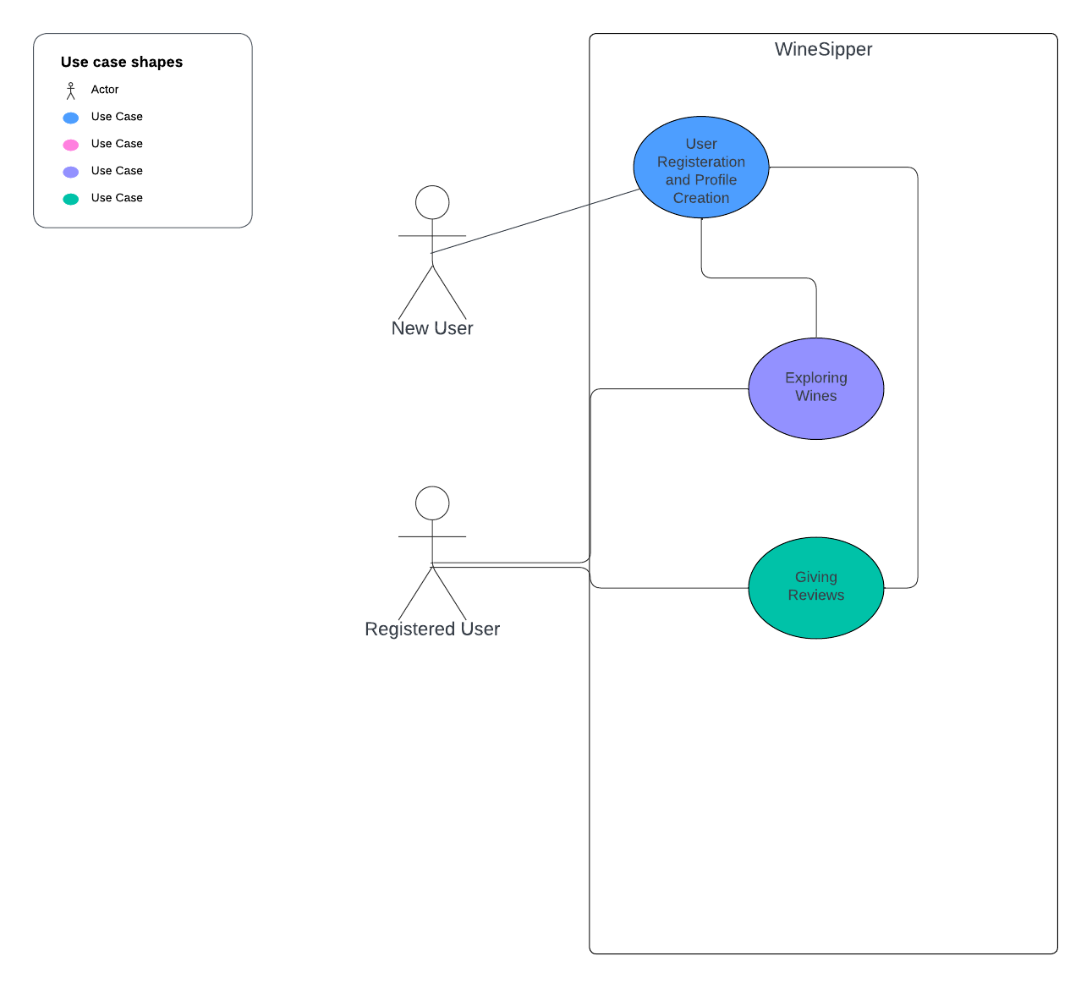

## Software Development Methodology

In developing the WineSipper , I have embraced an Iterative and Incremental Development Methodology (IID) complemented by the Scrum Framework to ensure a dynamic and effective approach to my project. This methodology involves breaking down the project into smaller, manageable components, enabling me to continually refine and enhance my work as I progress. With IID, I prioritize gathering feedback early and frequently, allowing me to adapt seamlessly to evolving requirements and priorities.

The Scrum Framework provides me with a structured framework for organizing and managing my project. I operate in short, focused iterations known as sprints, typically spanning a few weeks each. During each sprint, I establish specific goals and tasks. After each sprint, I conduct a thorough review of the progress, gather valuable feedback, and plan my next steps accordingly.

By integrating IID with the Scrum Framework, I aim to optimize efficiency, mitigate risks, and deliver exceptional results. My approach emphasizes agility, focus, and continual improvement as I towards achieving my objectives in developing the WineSipper.

## Project Timeline

## **February 5 to February 12, 2024:**

## Laid the groundwork and brainstormed ideas for WineSipper.

## Defined the project scope and objectives.

## Outlined the key features and functionalities of WineSipper.

## Created initial wireframes and mockups to visualize the website layout.

## **February 12 to February 28, 2024:**

## Intensive planning phase to translate ideas into actionable plans.

## Developed a comprehensive project plan.

## Created detailed user stories for each feature.

## Finalized the design and layout of the website, incorporating branding elements.

## **March 1 to March 25, 2024:**

## Development phase commenced with a focus on coding, testing, and refinement.

## Implemented front-end and back-end functionalities according to the defined specifications.

## Conducted regular code reviews and unit tests to ensure code quality and functionality

## Addressed any bugs or issues identified during testing promptly.

## **March 25 to April 2, 2024:**

## Finalized the development phase and prepared for submission.

## Implemented any remaining changes or enhancements based on feedback from testing

## Prepared documentation.

## Conducted final review and validation of all components.

## Packaged the website for submission, ensuring all files and configurations were in order.

## Prepared a comprehensive submission package, including documentation, source code, and any additional materials required.

## Known Bugs and Limitations

I have tried to keep the bugs and limitations to a minimum, regardless, there are a few. While adding wines, the user_id isn’t taken from the users table in the database, but needs to be manually enter by the user. I believe with bit more time on hand, I could have fixed it.

## Reflection

Embarking on the Wine Catalogue Project has been nothing short of an adventure filled with discoveries and growth, both personally and professionally. Here are some heartfelt reflections on this remarkable journey:

* Following My Heart: As someone who cherishes the world of wine, diving into this project felt like following my heart's desire. It's been an incredible journey exploring vineyards, learning about different grape varieties, and discovering the stories behind each bottle, all while sitting behind my screen.
* Putting Users First: At the heart of this project like any other project was a commitment to putting our users first. I poured my heart into creating an experience that not only met their needs but also brought joy and excitement to their wine exploration journey.
* Learning and Growing: The wine industry is vast and ever-evolving, and this journey has been filled with continuous learning and growth. Whether it's staying updated on the latest trends or honing our technical skills, every step has been an opportunity for personal and professional development.

To sum it up, the Wine Catalogue Project has been more than just a project—it's been a journey of passion, perseverance, and purpose. As we raise our glasses to what lies ahead, I'm filled with gratitude for the experiences shared and the possibilities that await us in this exciting venture. Cheers to the future!!!

## Reference

1. Names and relevant information about wines. <https://www.glengarrywines.co.nz/booking.jsp?id=6403>
2. Images.

<https://pixabay.com/>

1. CSS in bits.

<https://chat.openai.com/>

<https://stackoverflow.com/>